Introduction
Welcome to Business Report Training!

The MWC Quarterly and Annual reports are important and required to present the status of the MWC Association. This training document will take you the process of creating this report.
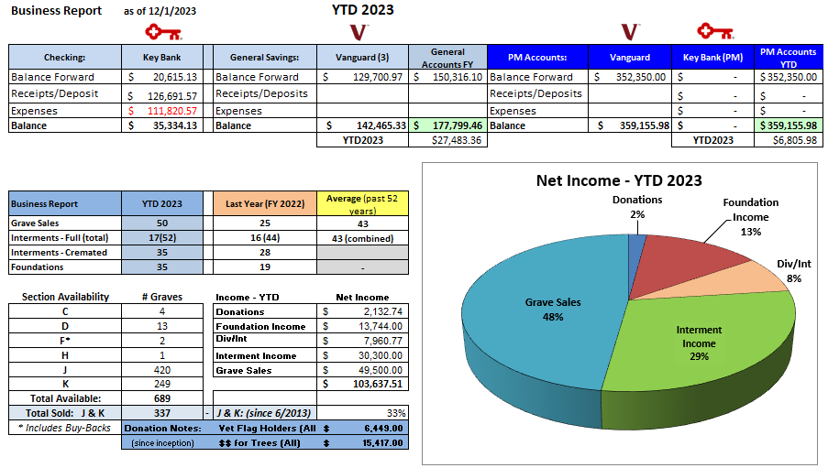
Below is a sample of the quarterly business report:

This is a complex report to generate and requires multiple sources. More details on how to create this report are provided in this ‘Business Reports’.

The NYS Cemetery Division documents and the Treasurer training documents are required to fully understand the requirements and content of this business report process.
A separate training document on how to create the correct Grave Sales numbers for both the Business Reports and the Permanent Maintenance (PM) reports.
Information needed for this business report requires data from:
- QuickBooks Online (QBO)
- KeyBank General Fund (GF) account
- Vanguard GF and PM accounts
- MS Access database
- MS Excel

