

Simmons Monument & Memorial Company, LLC
FOUNDATION ORDER
&
APPLICATION TO ERECT A MARKER OR MONUMENT

LOCATION: MAPLEWOOD CEMETERY APPLICATION#____________________
24 FLINTON RUN (OFFICE ADDRESS)
CHURCHVILLE, NY 14428
150 MIDDLE ROAD (CEMETERY) APPLICATION RECEIVED ___________

xxxx
MONUMENT: Base size: 2-6x1-0x1-4 Material: Granite

Die size: 2-0x0-10x1-4

MARKER: Size: _____in. _____in. _____in. Material:__________________

Name(s) of the deceased: Michael Cordello, Sr. and Joseph Cordello

Location: Sec K Row 25 Grave 11

Owner/Purchaser: Michael Cordello, Jr. Dealer: Simmons Monument & Memorial Co., LLC

Address: 76 Surrey Hill Way Address: 1191 N. Shore Pk

City, State, Zip: Rochester, NY 14623 City, State, Zip: Ontario, NY 14519

Telephone: 585-362-7484 Telephone: 585-298-0287

______________________________________
Authorized Signature, Monument Dealer
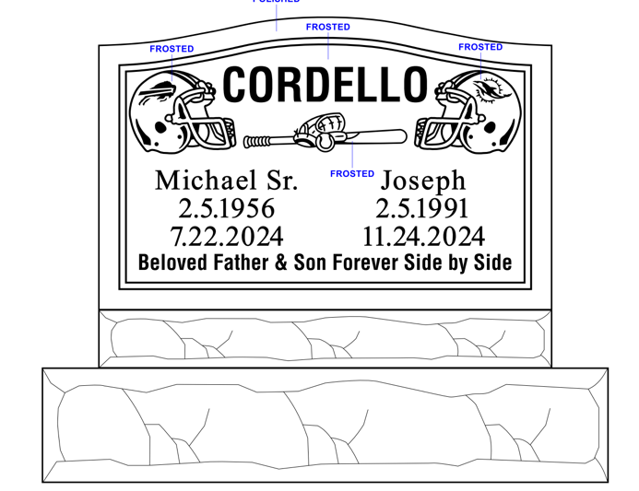

________________________________
Authorized Signature, Cemetery

