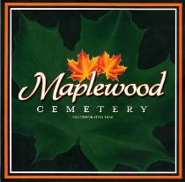
Maplewood Cemetery
Business Office
24 Flinton Run
Churchville, NY 14428
Hart Monument Co.
2301 Dewey Avenue
Rochester, NY 14615

New Pricing Information

