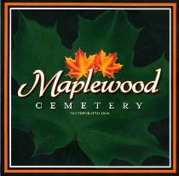
Maplewood Cemetery
Business Office
24 Flinton Run
Churchville, NY 14428
Derrick Monument Co., Inc.
37 Myrtle St.
Le Roy, NY 14482

New Pricing Information

